Assessment: Lab 8 Practice Exam

Student Name: Adam Di Cioccio

Lab Professor Name: Mohammad Patoary

Lab Section Number: 321

Due Date: November 24, 2020

# Pseudocode + Flowchart

***Psuedocode***

Import scanner

Boolean programIsRunning

Double num

Double total

Double totalGrade

String userInput

Int i

Create scanner

While loop (programIsRunning)

Reset doubles and int

For loop (int i < 5)

Prompt user

Set input into variable

Add users input to previous total

perform calculation to get average of the inputs

Print out results

Ask user if they want to continue

Gather input

Changer to uppercase

If statement (input = N)

Print out exiting

Close scanner

End while loop

Else if (input = Y)

Continue

***Flowchart***

Start

Declare variables: boolean programIsRunning, double num total totalGrade, int I, String userInput

Create scanner

While loop (programIsRunning)

Reset values

For loop (I <= 5)

Prompt user

Set input as num

Add num to total

End of for loop

Perform calulcations insert into totalGrade

Print results

Ask user to continue program (Y OR N)

If statement (Y=N)

Exiting program…

Stop

Else if (Y)

Continue

# Hand Trace

|  |  |  |  |  |
| --- | --- | --- | --- | --- |
| userInput | loopCounter | Output | Input (num) | total |
| “Y” | 1 | Enter Grade 1 | 1.0 | 1.0 |
| “Y” | 2 | Enter Grade 2 | 3.0 | 4.0 |
| “Y” | 3 | Enter Grade 3 | 2.0 | 6.0 |
| “Y” | 4 | Enter Grade 4 | 4.0 | 10.0 |
| “Y” | 5 | Enter Grade 5 | 5.0 | 15.0 |
| “Y” |  | Grade Average: 3.0  Continue Program? (Y/N) | “y” | 0.0 |
| “Y” | 1 | Enter Grade 1 | 2.0 | 2.0 |
| “Y” | 2 | Enter Grade 2 | 4.0 | 6.0 |
| “Y” | 3 | Enter Grade 3 | 4.0 | 10.0 |
| “Y” | 4 | Enter Grade 4 | 3.0 | 13.0 |
| “Y” | 5 | Enter Grade 5 | 1.0 | 14.0 |
| “N” | 5 | Grade Average: 2.8  Continue Program? (Y/N) | “N” | 0.0 |
| “N” |  | Exiting Program…  Adam Di Cioccio |  |  |

# Java screenshot

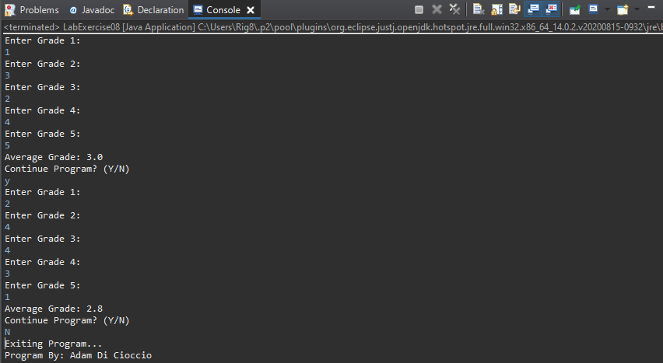

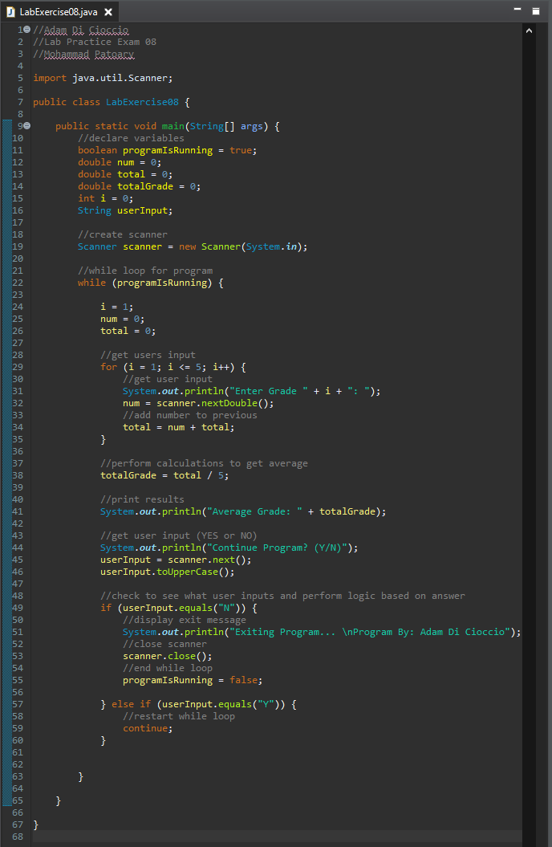

# Source Code for Program

//Adam Di Cioccio

//Lab Practice Exam 08

//Mohammad Patoary

import java.util.Scanner;

public class LabExercise08 {

public static void main(String[] args) {

//declare variables

boolean programIsRunning = true;

double num = 0;

double total = 0;

double totalGrade = 0;

int i = 0;

String userInput;

//create scanner

Scanner scanner = new Scanner(System.in);

//while loop for program

while (programIsRunning) {

i = 1;

num = 0;

total = 0;

//get users input

for (i = 1; i <= 5; i++) {

//get user input

System.out.println("Enter Grade " + i + ": ");

num = scanner.nextDouble();

//add number to previous

total = num + total;

}

//perform calculations to get average

totalGrade = total / 5;

//print results

System.out.println("Average Grade: " + totalGrade);

//get user input (YES or NO)

System.out.println("Continue Program? (Y/N)");

userInput = scanner.next();

userInput.toUpperCase();

//check to see what user inputs and perform logic based on answer

if (userInput.equals("N")) {

//display exit message

System.out.println("Exiting Program... \nProgram By: Adam Di Cioccio");

//close scanner

scanner.close();

//end while loop

programIsRunning = false;

} else if (userInput.equals("Y")) {

//restart while loop

continue;

}

}

}

}

# References / Sources Cited <<optional section, if needed>>